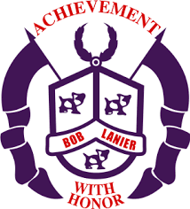**Bob Lanier Middle School**

**Shared Decision-Making Committee**

**January 29, 2021**

**AGENDA**

* **School Safety**
* Physical
* **Coronavirus Protocols/Updates**
* **Nurse as primary communication**
* **90% of Lanier transmissions are happening this way**
* **N95s???**
* Emotional
* PUPS
* Social Worker, Wrap Around Specialist, Intern
* PLC #1: What do we want our children to know and be able to do?
* **Team collaboration**
  + **Department Meetings**
  + **PLCs (Curriculum Teams)**
* PLC #2: How will we know if our children have learned what we want them to learn?
* **CFU/Daily/Weekly Assessments**
* Common Assessments
* Renaissance 360
* DLA
* Final Exams
* PLC #3: How will we respond when, despite our best efforts, we discover that some of our children have not learned what we want them to learn?
* Tier 1: regular classroom instruction
* Tier 2: Asynchronous instruction, Office Hours, Boot Camp
* Tier 3: Math interventionist, Reading Interventionist

ABC – Academic Boot Camp: Dr. Colburn

* PLC#4: How will we respond when we discover that some of our children already know what we want them to learn and be able to do?
* **New Business:**
  + **Late Work Policy**
  + **Regular Budget**
  + **Hiring Freeze**

**Meeting Adjourned**